Chapter test

Chapter 7 Reactions in aqueous solutions

Name:

Class:

Time permitted: 30 minutes

|  |  |  |  |  |
| --- | --- | --- | --- | --- |
|  | Section | Number of questions | Marks available | Marks achieved |
| A | Multiple choice | 15 | 15 |  |
| B | Short answer | 5 | 15 |  |
|  | Total |  | 30 |  |

Grade:

Scale:

|  |  |  |  |  |  |  |  |  |  |  |  |  |  |
| --- | --- | --- | --- | --- | --- | --- | --- | --- | --- | --- | --- | --- | --- |
| A+ | 29–30 | A | 26–28 | B | 23–25 | C | 19–22 | D | 15–18 | E | 9–14 | UG | 0–8 |

Comments:

Section A Multiple choice (15 marks)

Section A consists of 15 questions, each worth one mark. Each question has only one correct answer. Circle the correct answer. Attempt all questions. Marks will not be deducted for incorrect answers. You are advised to spend no more than 15 minutes on this section.

1 Which of the following is not a solution?

A Alloy

B Mercury

C Soft drink

D Air

2 The solubility of sodium chloride in water is 36 g/100 g at 25°C. If 38 g of sodium chloride was added to 100 mL of water at the same temperature, what would the solution be classified as?

A Saturated

B Unsaturated

C Supersaturated

D Insoluble

3 Which of the following is not a representation of potassium chloride dissolving in water?

A KCl(s)  K+(aq) + Cl–(aq)

B K+(aq) + Cl–(aq)  KCl(aq)

C KCl(s)  KCl(aq)

D KCl(s)  K+(aq) + Cl–(aq)

4 Which of the following is correct?

A Precipitation is the opposite of dissolving.

B All precipitates have a colour.

C Temperature does not affect precipitation.

D Not all precipitation reactions contain spectator ions.

For questions 5–7 refer to the information below.

|  |  |
| --- | --- |
| Soluble anions | Exceptions |
| NO3– | None |
| CH3COO– | Ag+ slightly soluble |
| Cl– | Ag+ insoluble, Pb2+ slightly soluble |
| Br– | Ag+ insoluble, Pb2+ slightly soluble |
| I– | Ag+, Pb2+ insoluble |
| SO4– | Ba2+, Pb2+, Sr2+ insoluble, Ag+, Ca2+ slightly soluble |
| Insoluble anions | Exceptions |
| OH– | Group 1, NH4+, Ba2+, Sr2+ soluble; Ca2+ slightly soluble |
| O2– | Group 1, NH4+, Ba2+, Sr2+, Ca2+ soluble |
| S2– | Groups 1 and 2, NH4+ soluble |
| CO32– | Group 1, NH4+ soluble |
| SO32– | Group 1, NH4+ soluble |

5 Which of the following solutions would form a precipitate when mixed with a solution of copper(II) sulfate?

A Potassium nitrate

B Sodium sulfate

C Potassium chloride

D Sodium hydroxide

6 Which of the following combinations does not produce a precipitate?

A Sodium carbonate and silver nitrate

B Silver nitrate and potassium chloride

C Potassium nitrate and copper(II) sulfate

D Barium chloride and sodium sulfate

7 Which of these substances could be added to barium hydroxide to form two precipitates?

A BaCl2

B NaNO3

C CuSO4

D KNO3

8 A student adds 100 mL of deionised water to 50.0 mL of a 0.025 mol L–1 solution of CuSO4. The concentration of the diluted solution is:

A 8.3 × 10–3 mol L–1.

B 1.25 × 10–2 mol L–1.

C 120 mol L–1.

D 0.05 mol L–1.

9 Which of the following are usually basic?

A Soft drink

B Proteins in food

C Household cleaners

D Rain

10 Which of the following is true?

A All alkalis are bases.

B All bases are alkalis.

C Acids produce hydrogen gas in aqueous solution.

D Bases produce oxygen gas in aqueous solution.

11 When an acid reacts with a base:

A a salt and hydrogen gas are produced.

B carbon dioxide and water are produced.

C the pH of the solution is always neutral.

D the pH of the solution is not always neutral.

12 The pH scale:

A ranges from 0 to 14.

B ranges from 0 to 7, which is neutral.

C is equal to the pOH scale.

D is based on the concentration of H+ and OH– ions in solution.

13 The hydroxide ion concentration of a solution equals 10–(14–pH). The hydroxide ion concentration of a solution with pH of 4 equals:

A 1010.

B 10–10.

C 104.

D 10–4.

For questions 14 and 15 refer to the indicator chart below.

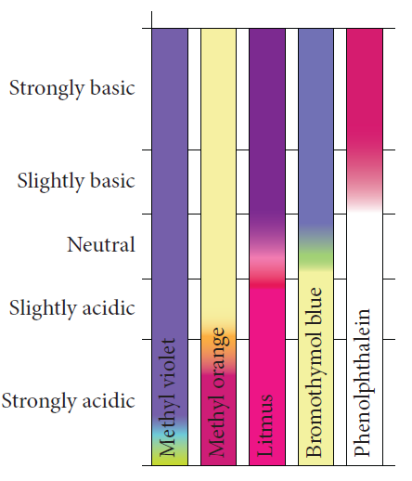

14 A solution was tested with all five indicators. Two of the indicators turned yellow. The solution can be described as:

A strongly acidic.

B slightly acidic.

C slightly basic.

D strongly basic.

15 A student wanted to test the pH of a blue copper(II) carbonate solution. Which indicator would be the correct one to use?

A Any indicator

B None of the indicators

C Phenolpthalein

D Bromothymol blue

Section B Short answer (15 marks)

Section B consists of five questions. Write your answers in the spaces provided. You are advised to spend 20 minutes on this section.

1 a Calculate the concentration of a solution prepared by dissolving 4.80 g of copper sulfate in 250 mL of solution. (2 marks)

b Convert this concentration to grams per litre. (1 mark)

2 This diagram shows a piece of equipment used in the laboratory to make up solutions.

Outline a method to produce 250 mL of a 0.020 mol L–1 solution of potassium nitrate using this apparatus. Include any necessary calculations in your answer. (3 marks)

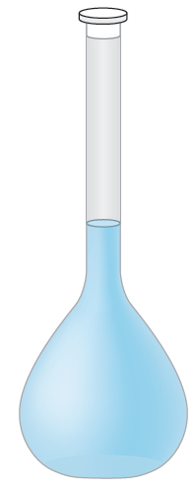

3 a A student has 25 mL of a 0.10 mol L–1 hydrochloric acid solution. How much water must be added to prepare a 0.025 mol L–1 solution? (2 marks)

b Name a piece of glassware that is used during a dilution, other than the one shown in question 2. (1 mark)

4 A student adds solid calcium hydroxide to 50 mL of a 0.350 mol L–1 hydrochloric acid solution.

a Write a balanced chemical equation for this reaction. (1 mark)

b Calculate the mass of calcium hydroxide needed to neutralise the acid.   
(2 marks)

5 A student carried out a number of tests using the HCl solution and the resulting product solution produced in question 4. She had phenolphthalein, methyl orange, bromothymol blue and the following chart available.

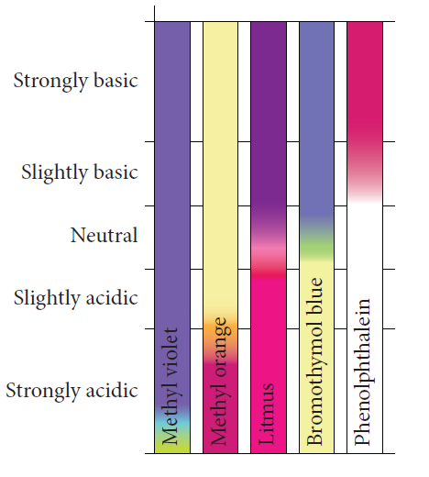

a Draw a table to identify the colour each indicator would appear in the HCl solution and the product solution. (2 marks)

b Describe a qualitative test you could do, naming the chemical required, to confirm the presence of chloride ions in the resulting solution. (1 mark)

End of test (30 marks)